Site: 018
Latitude: 55.29947264
Longtitude: -162.7196128
Dates Surveyed: 8/5 - 8/6/2025
Anadromous fish species captured: Coho Salmon
Notes: Sampled on the ground on 8/5/2025. The stream channel is defined with flowing water between multiple connected lakes. Quality fish habitat is present in the stream channel and in lakes. Stream flows north into Izembek Lagoon. Captured Coho salmon, threespine stickleback, and slimy sculpin.

Photographs

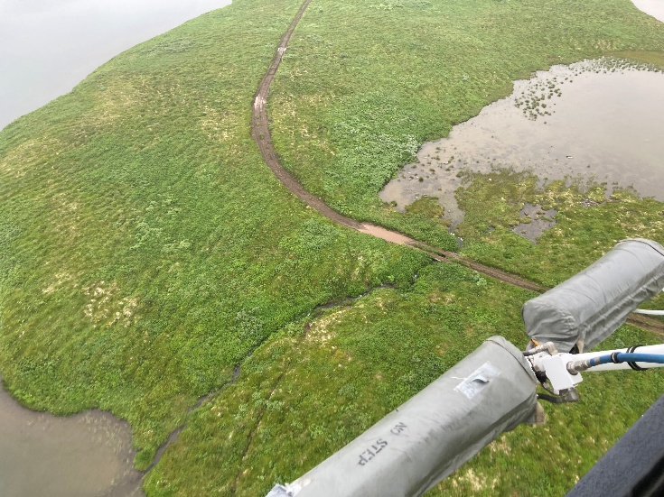 | 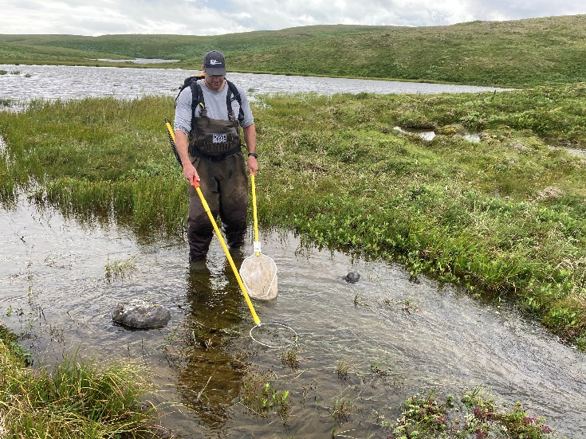
Photo looking southeast, stream flowing from right to left. | Electrofishing the pond outlet immediately upstream from the road crossing, looking south. Stream flowing from left to right.
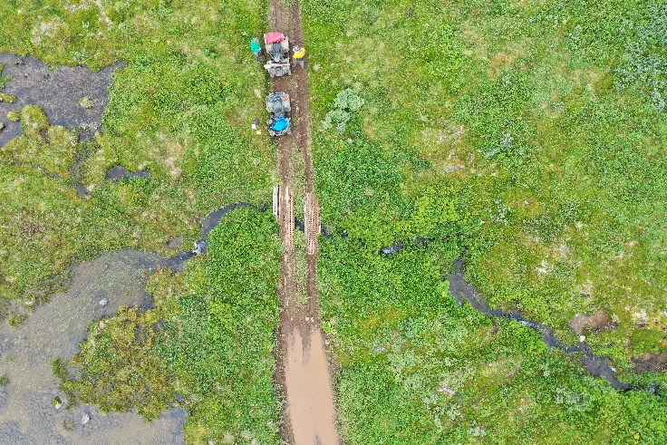 | 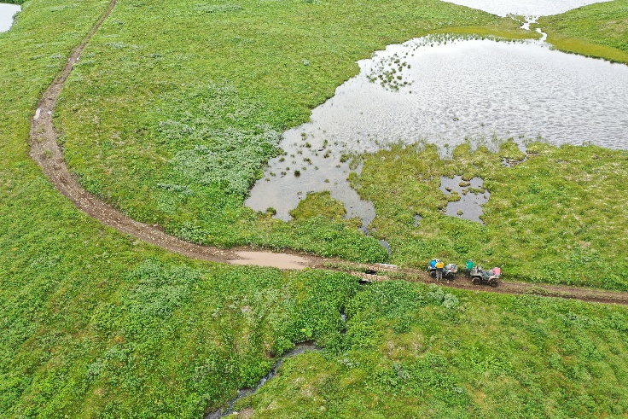
Photo looking at road crossing directly overhead, stream flowing from left to right. | Photo looking upstream to the southeast.

Photographs
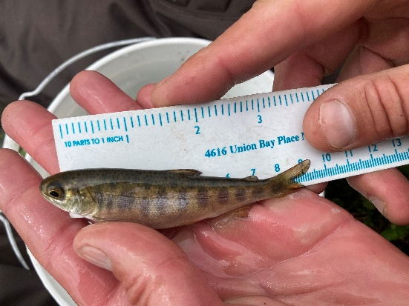 | 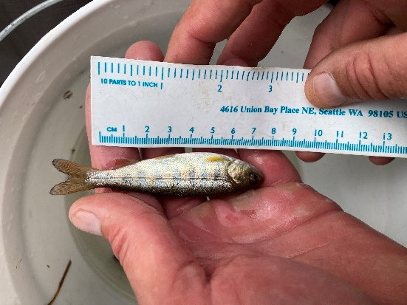
Juvenile Coho Salmon captured from Stream Crossing 018. | Juvenile Coho Salmon captured from Stream Crossing 018.

